
  - PROject tittle: Speeding Enforcement Dashboard
  - Group NO: 31
- Team MEMBERS | - Student IDS
- SHENG YANG HO | - 102786991
- PRINCE CHIKUKWA | - 102784429
- JIAQI HU | - 104384193

  - (https://cos-30045-speeding-dashboard.vercel.app/)
2025
Semester 2
(Word Count)

Table of Contents
Contents
Table of Contents 0
1 Introduction 2
1.1 Background and Motivation 2
1.2 Visualisation Purpose 2
1.3 Project Scope and Overview 3
2 Data 4
2.1 Data Source and Governance 4
2.2 Data Processing and Analysis 6
2.2.1 Key attributes and data types 6
2.2.2 Data Processing 7
2.3 Data Exploration 8
3 Visualisation Design 10
3.1 Website Design 10
Storyboard 13
Storyboard Sequence 13
3.2 Visualisation Design 17
3.3 Interaction Design 19
4 Iteration and Validation 20
4.1 Testing and refinements 20
4.2 Usability evlauation 22
5 Conclusion and Future Improvements 23
5.1 Conclusion 23
5.2 Limitations 23
5.3 Future Improvements 24
References 24
Appendices 24

1 Introduction

Background and Motivation
Road safety continues to be a national priority due to its significant social and economic impact. Speeding remains one of the most common road offences, and understanding how speeding fines vary across years, states, age groups, and enforcement methods provides important insights for policy and community behaviour.

The Bureau of Infrastructure and Transport Research Economics (BITRE) publishes detailed enforcement datasets covering speeding fines issued by police and automated camera systems across all Australian jurisdictions. These open datasets provide an opportunity to transform large, complex tabular records into meaningful and accessible visual insights.

This project uses the BITRE Road Safety Enforcement dataset (2008–2024) to develop an interactive web-based dashboard that explains patterns in speeding enforcement through a clear, question-focused visual analytics approach. The dashboard aims to simplify data interpretation and present key findings in a way that supports both learning and public understanding.

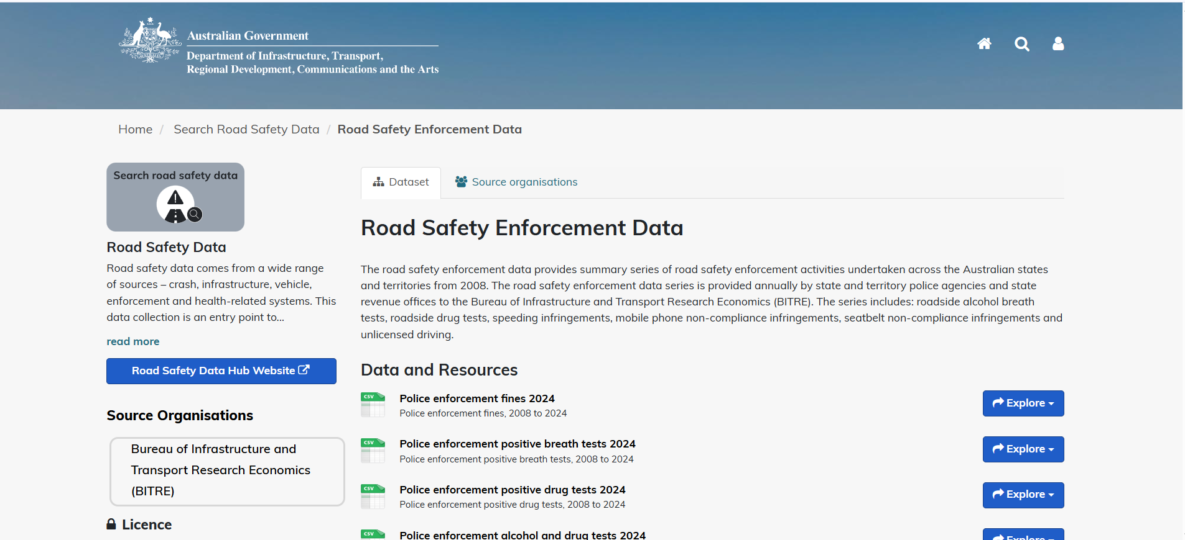

Visualisation Purpose
The purpose of this project is to design a simplified, question-driven dashboard that uses D3.js to communicate insights from the BITRE dataset. Instead of relying on multiple filters or a fully exploratory interface, the final dashboard adopts a structured design where each visualisation directly answers one of five targeted research questions:
- Which jurisdiction has the highest fine amount imposed?
- What are the changes in speed enforcement measures between 2023 and 2024?
- In 2024, which age group received the most speeding fines?
- Which states recorded the highest average fine amounts in 2024?
- In 2024, which Australian state recorded the most speeding fines for the 0–16 age group?
Each question is supported by a dedicated dataset (Q1–Q5) that has been cleaned and aggregated specifically for the final visualisation. A different D3.js chart type is used for each question—bar, column, pie, area, and line—selected to best represent the structure of the underlying data. The objective is to provide clear, targeted insights through effective visual storytelling while maintaining usability and a consistent design.

1.3 Project Scope and Overview
The project includes three major components:
- Data Processing:
Five derived CSV files were produced (Q1–Q5), each containing only the fields required for its respective visualisation. Data preparation included cleaning, aggregation, grouping by jurisdictions, age groups, enforcement type, and mean calculations for fine amounts.
- Web Implementation:
A three-page website (Home, Dashboard, About) was developed using HTML, CSS, and D3.js. Each visualisation is embedded into a modular card component, supported by interactive tooltips and highlight features.
- Analysis and Communication:
Each visualisation includes a descriptive heading, a short explanation, and an automatically generated textual answer summarising the key insight.
The completed system delivers a structured and accessible digital tool that supports the interpretation of road safety enforcement trends across Australia.

2 Data

2.1 Data Source and Governance
Original Data Source
Data is sourced from the Department of Infrastructure, Transport, Regional Development, Communications and the Arts (DITRDCA) through its agency, the Bureau of Infrastructure and Transport Research Economics (BITRE).
Official dataset link:
👉 https://catalogue.data.infrastructure.gov.au/dataset/road-safety-enforcement-data
BITRE works with all state and territory police forces and revenue agencies to collect annual enforcement data.
Participating agencies include:
- NSW Police Force & NSW Revenue
- Victoria Police
- Queensland Police Service
- South Australia Police
- Western Australia Police Force
- Tasmania Police
- Northern Territory Police
- Australian Federal Police / Access Canberra

Table 1: Dataset Summary
Dataset | Records | Key Attributes | Time Period | Source | Update Frequency
Police enforcement fines 2024 | ≈ 35 000 | Year, Jurisdiction, Offence Type, Detection Method, Fine Count | 2008–2024 | BITRE | Annual
Police enforcement positive drug tests 2024 | ≈ 3 000 | Year, Jurisdiction, Positive Rate, Detection Method, Age Group | 2008–2024 | BITRE | Annual
Police enforcement positive breath tests 2024 | ≈ 3 000 | Year, Jurisdiction, Positive Count, Detection Method | 2008–2024 | BITRE | Annual

Data Governance
Data Collection Process:
BITRE consolidates enforcement data provided annually by each state and territory. Some agencies report both police-issued and camera-issued fines, while others have separate authorities managing camera detections (e.g., Access Canberra for ACT). Data is cleaned, validated, and harmonised before national publication.
Data Quality Assessment:
The 2024 dataset is comprehensive but includes limitations such as missing values for specific years or states (e.g., incomplete ACT or Victorian data during industrial action). Data since 2023 includes monthly granularity, age group, detection method, and remoteness fields, improving accuracy
Road safety enforcement data di…
.
Security, Privacy, and Ethics:
The datasets contain no personal or identifiable information — all data are aggregated by jurisdiction, offence type, and time period. Usage complies with Australia’s Open Government Data Policy and Swinburne University ethical standards. Responsible usage is acknowledged in accordance with BITRE’s open-data licence.

Table 2: Research Questions and Data Support
Research Question | Relevant Dataset(s) | Key Attributes / Variables | How the Data Supports the Question
1. Which jurisdiction has the highest fine amount imposed? | police_enforcement_2024_fines.csv | Year, Jurisdiction, Fines | Enables per-capita comparisons between states and territories.
2. What are the changes in the speed enforcement measures for the years 2023 and 2024? | police_enforcement_2024_fines.csv | Year, Metric, Detection Method | Allows temporal analysis of enforcement decline or increase.
3. In 2024, which age group had the most speeding fine records? | police_enforcement_2024_fines.csv | Year, Age group, Fines | Supports trend comparison of detection methods over time.
4. Which states have the highest average fine amounts? | police_enforcement_2024_fines.csv | Jurisdiction, Fines | Enables variability and standard deviation analysis.
5. In 2024, which Australian state had the most speeding fine records for the 0–16 age group? | police_enforcement_2024_fines.csv | Year, Jurisdiction, Fines, Age group | Global view analysis of data and presentation of results.

2.2 Data Processing and Analysis

2.2.1 Key attributes and data types
- The dataset contains several key attributes that were examined prior to analysis. Each attribute was classified according to its data type (string or numeric) and measurement level (categorical, ordinal, interval, or ratio). Table 3 summarises the main attributes used in the study.
Table 3: …
Key Attribute | Data Type | Measurement Type | Short Description
Jurisdiction | String | Categorical | State or territory
Detection Method | String | Categorical | Camera or police-issued
Fines | Number (double0 | Quantitative | Number of fines issued
Year | Number (integer) | Interval | Year of enforcement

2.2.2 Data Processing
- Describe the data cleaning process (in KNIME), including:
  - Handling missing values
  - Removing duplicates
  - Normalisation, transformation, and derived variables
  - Calculated derived metrics
- The dataset underwent several preprocessing steps in KNIME to ensure that it was clean, consistent, and ready for analysis. These steps involved handling missing values, transforming variables, calculating derived metrics, filtering records, and joining multiple datasets. Table 4 lists the nodes used and their purposes.
Table 4: …
KNIME Node Used | Purpose | Output
Missing Value node | To detect and fill or remove missing values from numeric or categorical columns. | Replaced missing offence counts with “0” or excluded incomplete jurisdiction-year rows.
Math Formula / GroupBy node | To create new calculated columns such as rates or totals. | Camera Growth Rate: camera_growth = (CameraIssued - CameraIssued_lag) / CameraIssued_lag * 100
Row Filter / Rule-based Row Filter | To select only relevant offences or years for visualisation. | Filtered data to 2010–2024 for selected dashboard category (e.g., Drug Tests).
Joiner node / Concatenate node | To combine multiple datasets into one table for comparison. | Merged datasets using common keys (Year, Jurisdiction) to create a unified dataset for analysis.
- Include a screenshot of the KNIME workflow for data processing
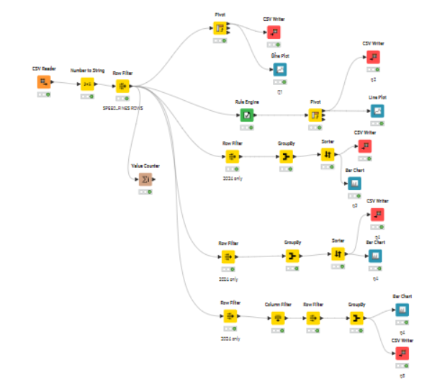
Figure 2

2.3 Data Exploration
- Conduct exploratory data analysis using KNIME.
- Provide summary statistics (basic descriptive statistics) and data visualisations to understand patterns and outliers
- Include a screenshot of the KNIME workflow for data cleaning
Table 5: …
KNIME Node Used | Purpose of the Node | Example Output / Description
Statistics | Generates basic descriptive statistics (mean, min, max, standard deviation). | Summary table showing average fines and test counts per year.
Data Explorer | Provides an overview of column distributions, missing values, and outliers. | Identifies missing Jurisdiction values or abnormal Positive Rates.
GroupBy | Aggregates data to calculate totals or averages per category. | Summarises total fines by Year and Jurisdiction.
Box Plot | Detects outliers and visualises data spread. | Visualises high fine counts in NT compared to other states.
Bar Chart | Displays category comparisons. | Shows number of fines per offence type.
Line Plot | Shows trends over time. | Plots fines or tests from 2008–2024.
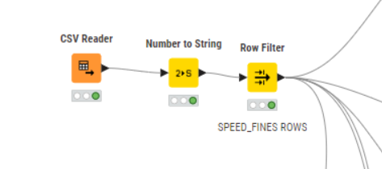
Figure 3
- Discuss initial observations (a summary of what you discovered)
- Reflection:
  - What insights or anomalies did you find?
  - Which variables are most relevant to your research questions?
  - Any challenges (e.g., missing data or inconsistent reporting)?
Table 6:
Research Question | Key Findings from KNIME EDA | Initial Observations / Insights | Charts Produced in KNIME
1. Which jurisdiction has the highest fine amount imposed? | Victoria has the highest total fines. | Jurisdictional variation is clear — possible link to enforcement intensity. | 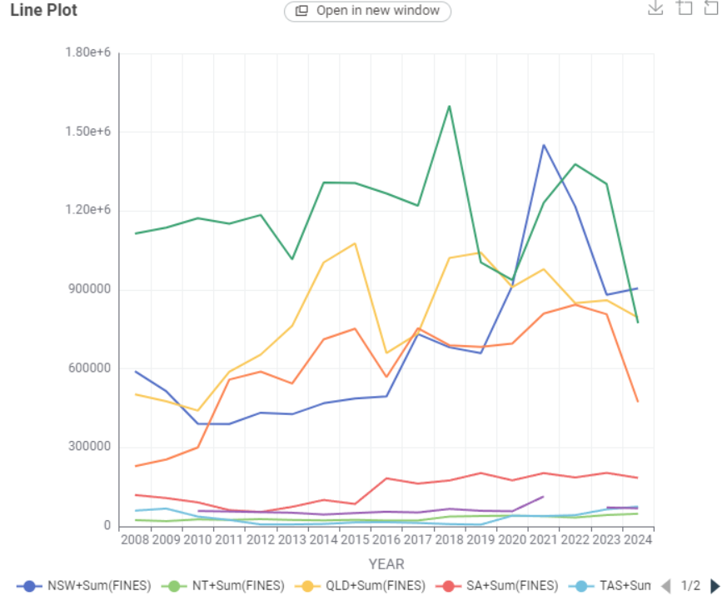
2. What are the changes in the speed enforcement measures for the years 2023 and 2024? | Camera fines decreased, police fines remained stable | Initial observations indicate that in 2024, the variety of law enforcement body cameras increased, and the number of penalties rose significantly compared to 2023. | 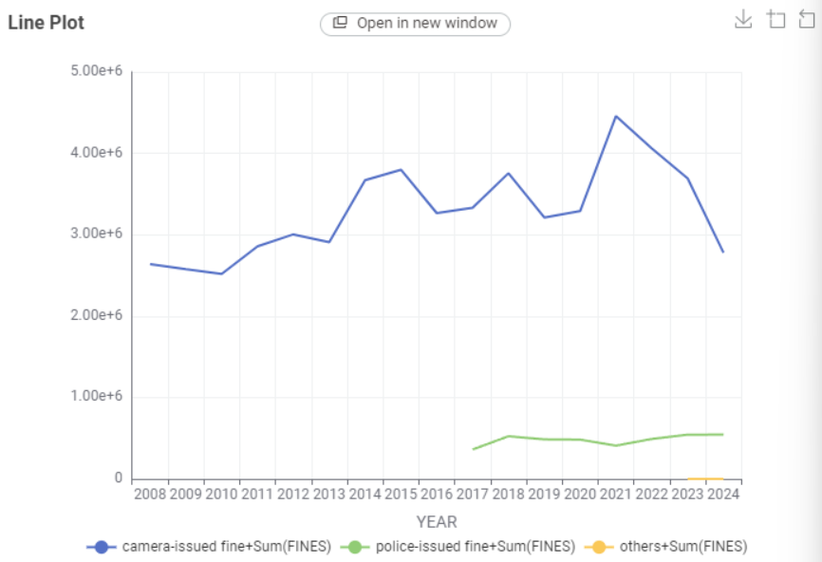
3. In 2024, which age group had the most speeding fine records? | 40-64 | The 40–64 age group received the most speeding fines in 2024, likely due to higher road usage. | 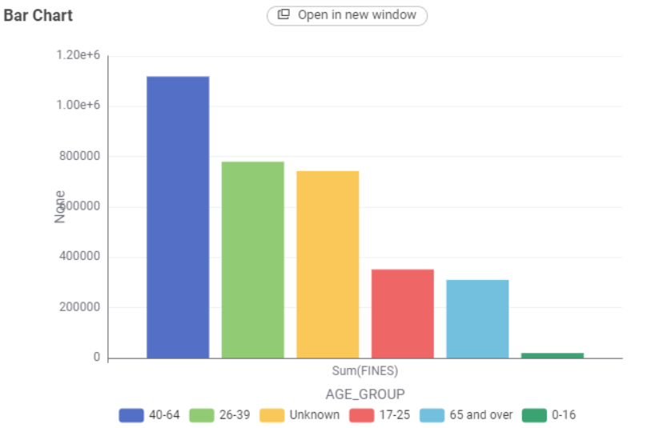
4. Which states have the highest average fine amounts in 2024? | QLD (Queensland) | Queensland had the highest average fine amounts in 2024, suggesting stricter penalties. | 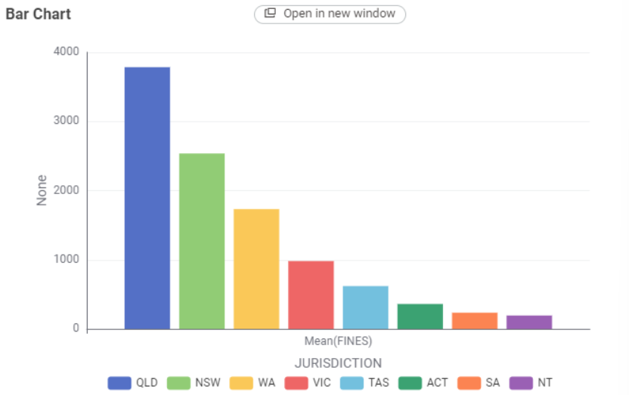
5. In 2024, which Australian state had the most speeding fine records for the 0–16 age group? | QLD (Queensland) | Queensland recorded the most 0–16 speeding offences in 2024, indicating more young-age violations there. | 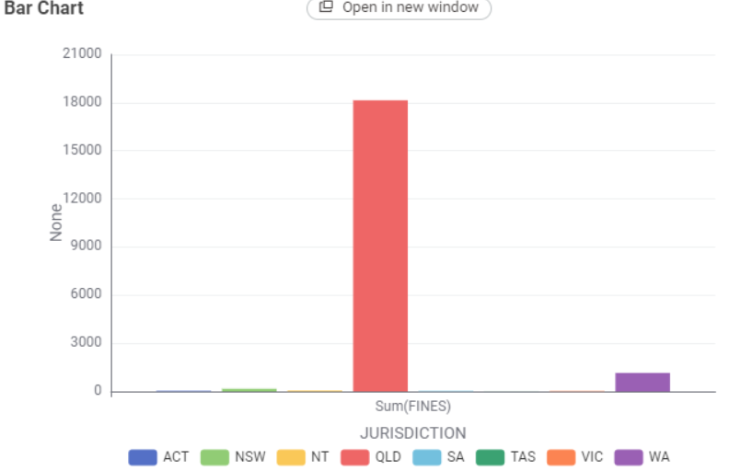

3 Visualisation Design
This section should include:

Website Design
The website was designed as a three-page interactive dashboard consisting of a Home page, Dashboard page, and About page. The layout follows a clean and minimal structure, ensuring readability, intuitive navigation, and smooth interaction across devices. The design adopts a consistent dark theme with blue highlights to support visual contrast and maintain aesthetic unity.

Wireframe Description
The wireframe outlines the core layout structure of the website. Although the final version was implemented directly in HTML/CSS and D3.js, wireframes were created to guide the placement of visual elements.
Navigation Structure (Top-Level Layout)
All pages share a fixed top navigation bar containing:
Logo + Project Title (left)
Navigation Links: Home | Dashboard | About (right)
This persistent navigation ensures that users can move between pages at any stage of interaction.
Home Page Wireframe Structure
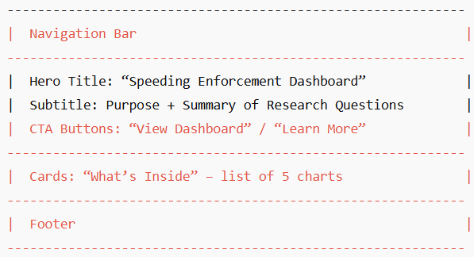

Dashboard Page Wireframe Structure
Each chart is placed inside an independent card:
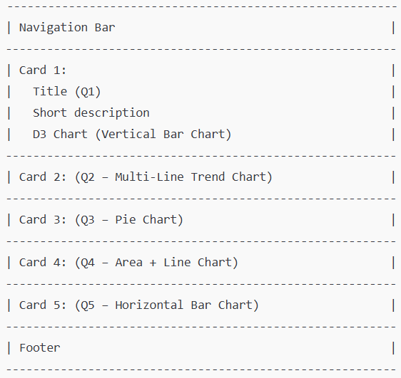

About Page Wireframe Structure
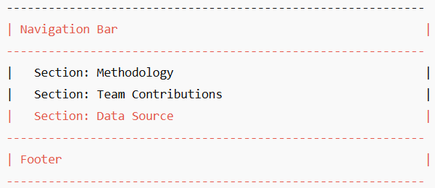
These wireframes ensure that visualisation content remains modular, readable, and consistent across the entire site.

Planned Structure and User Flow
The website follows a linear user flow designed to support progressive understanding:
- Users land on the Home page, where they learn:
  - What the project is about
  - What the dashboard contains
  - What research questions will be answered
- From the Home page, users navigate to the Dashboard using:
  - The navigation bar
  - The “View Dashboard” call-to-action button
- The Dashboard page presents all five visualisations in a vertical sequence (Q1 → Q5).
Users scroll downward to explore each chart in order.
- Each chart card provides:
  - A D3 visualisation
  - A descriptive explanation
(Note: automatic written answers were removed in the final design.)
- Users may visit the About page to read more context, methodology, and project roles.
This user flow is intentionally simple to minimise cognitive load and ensure clarity of interpretation.

Storyboard
The storyboard demonstrates how a typical user interacts with the dashboard. Although the dashboard does not contain dropdown filters, it emphasizes scroll-based exploration and hover-based interaction.

Storyboard Sequence
Step 1 — User Arrives on Home Page
- User reads the project motivation and research questions.
- User clicks “Open Dashboard” or navigates via the navbar.
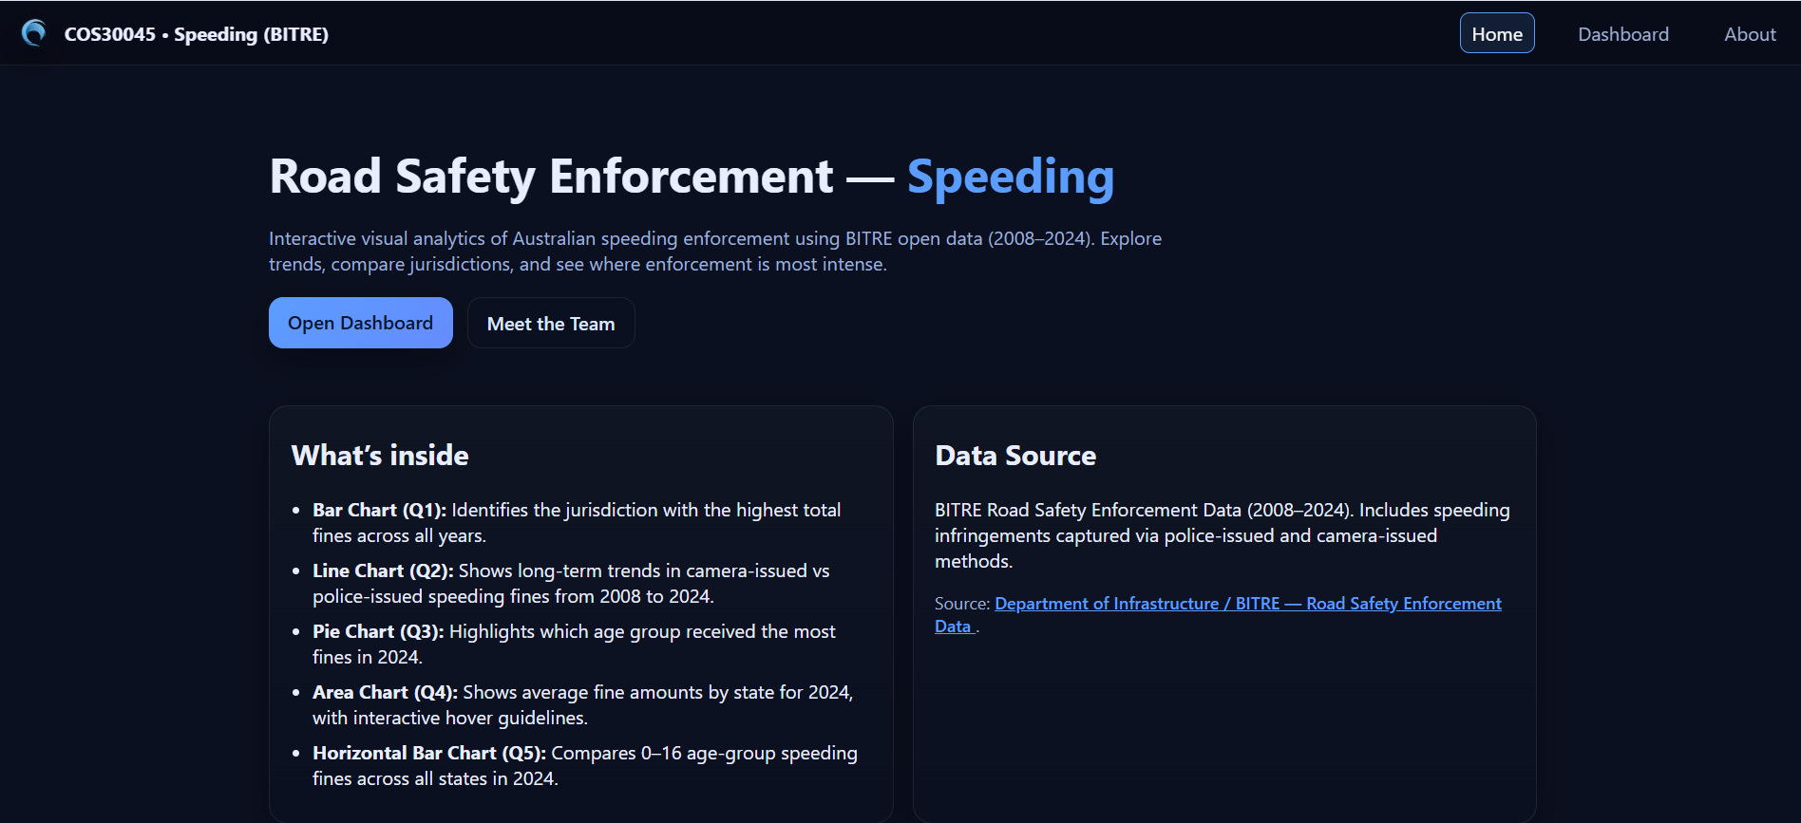
Step 2 — Dashboard Loads All Visualisation Cards
- Q1 vertical bar chart appears first.
- Tooltip shows jurisdiction and total fines on hover.
- The highest-fine jurisdiction is highlighted in orange.
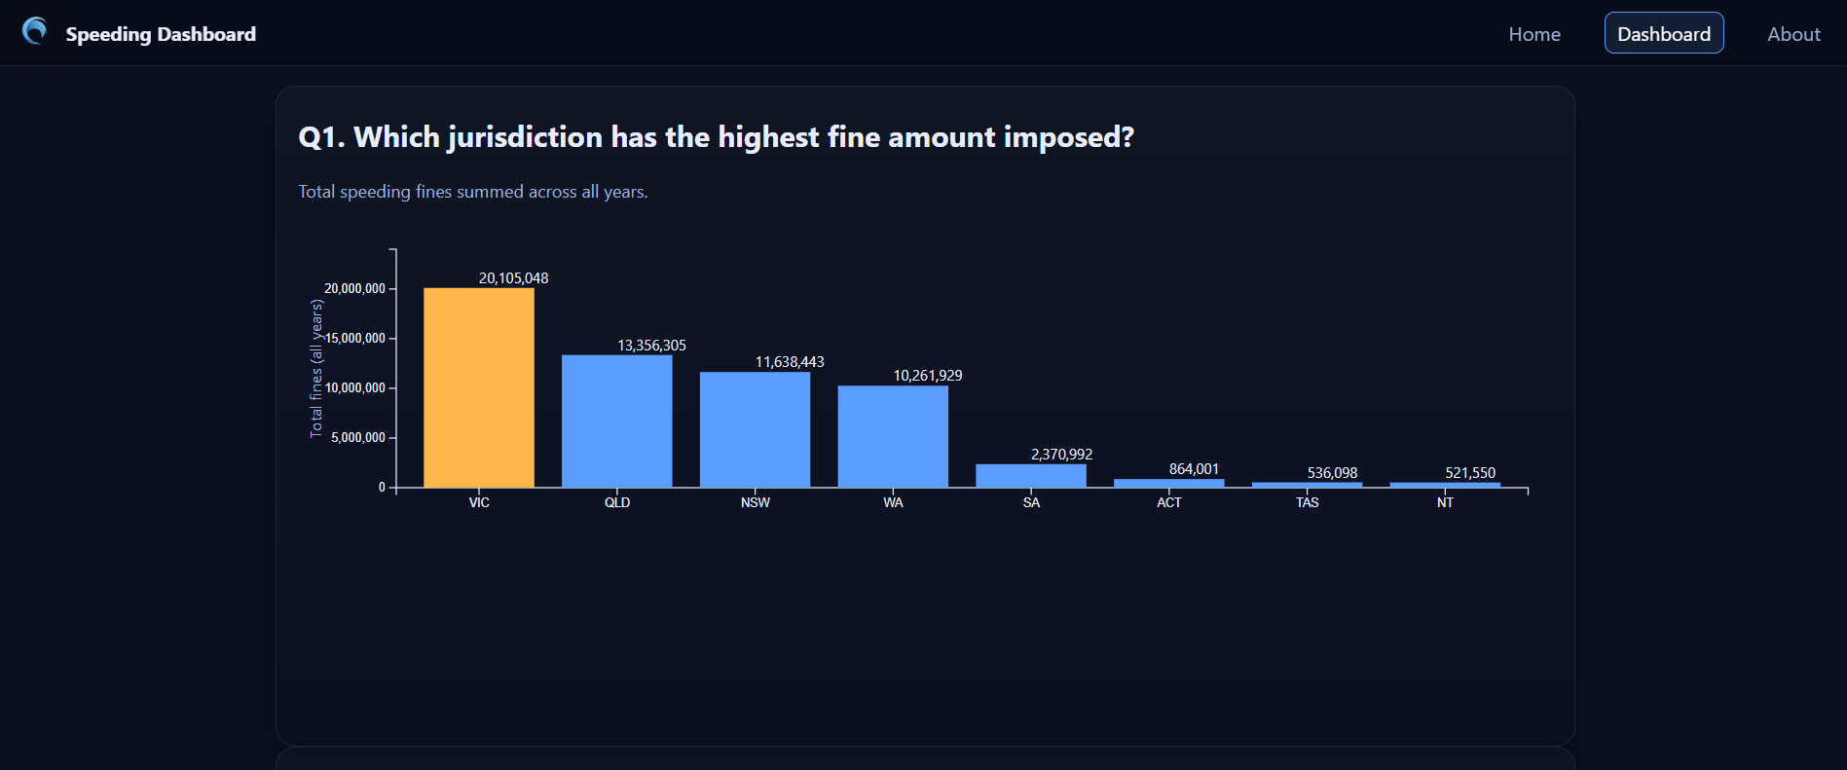
Step 3 — User Scrolls to Q2 (Multi-Line Trend Chart)
- User sees three lines: camera-issued, police-issued, and others.
- Hovering displays a vertical dotted guideline following the cursor and shows all values for the nearest year.
- User observes long-term enforcement trends.
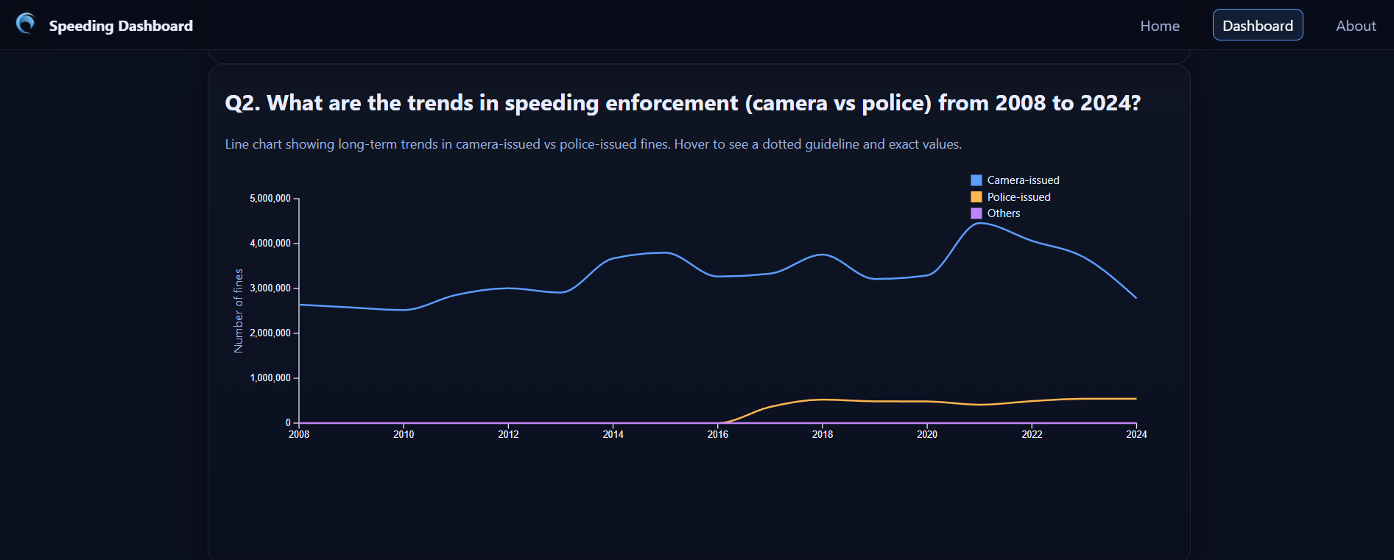
Step 4 — User Scrolls to Q3 (Pie Chart)
- Pie slices animate into place.
- Larger slices show internal labels; smaller slices have external labels with leader lines.
- Hover reveals the fines and labels clearly.
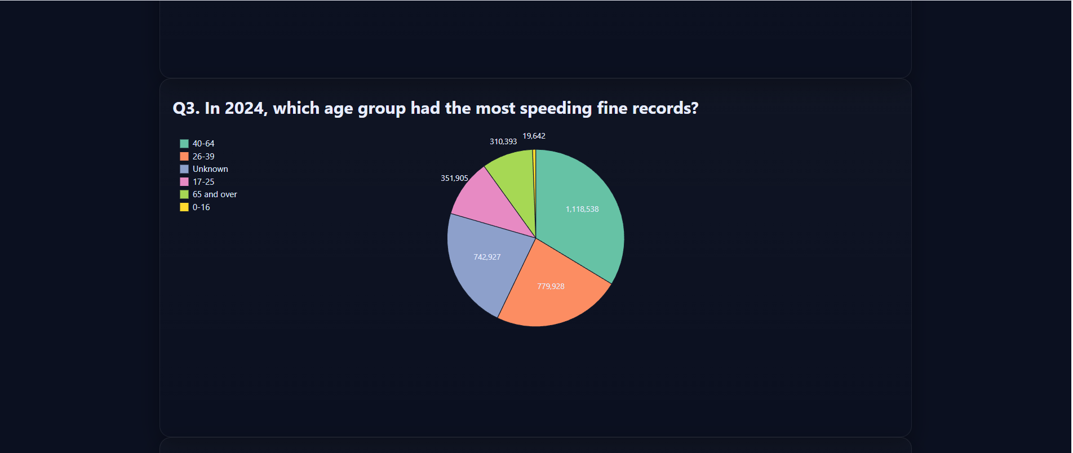
Step 5 — User Scrolls to Q4 (Area + Line Chart)
- The highest-value state is highlighted to draw user attention immediately.
- Value labels appear clearly beside each bar for readability.
- Hovering shows a horizontal guideline and a tooltip with the exact average fine amount.
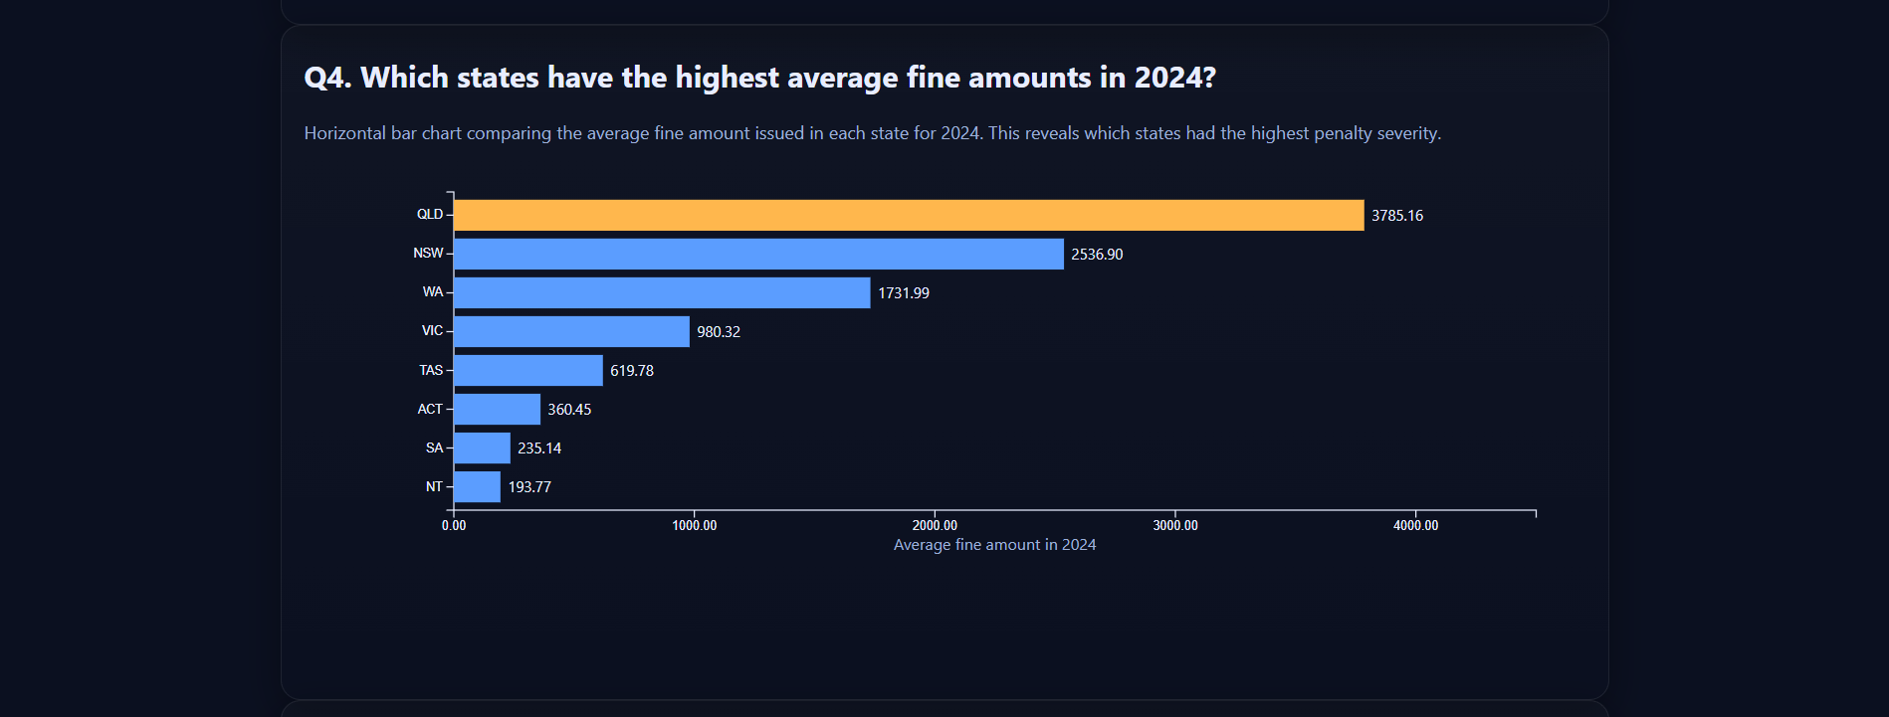
Step 6 — User Scrolls to Q5 (Horizontal Bar Chart)
- Bars animate from left to right.
- A square-root scale makes small values visible.
- Hover reveals a horizontal guideline and tooltip with the fine count for the 0–16 age group.
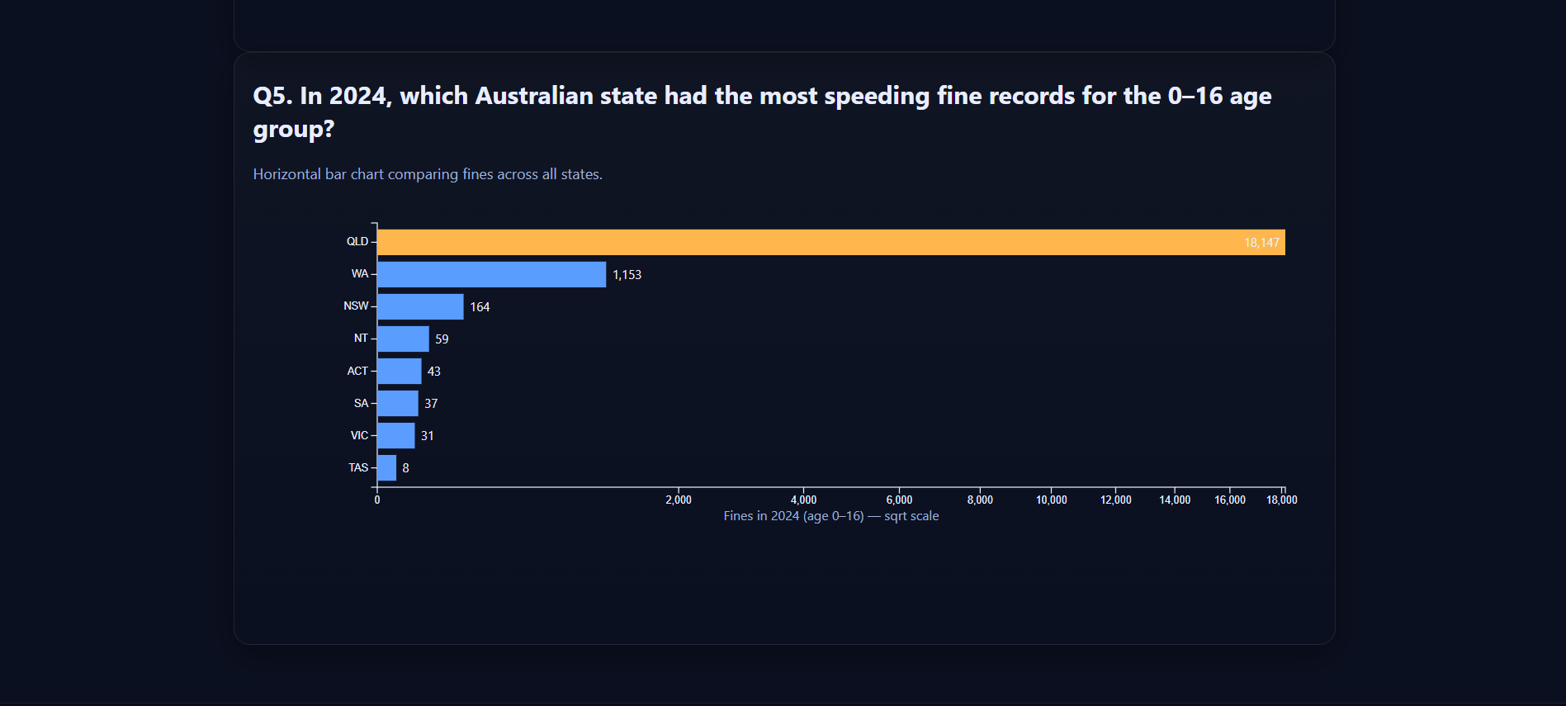
Step 7 — User Visits the About Page
- User reads methodology, data source, and team roles.
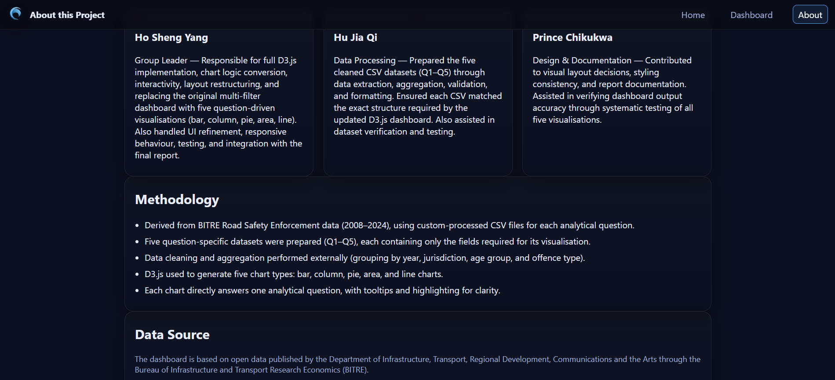
This storyboard illustrates a smooth flow from introduction → investigation → explanation.

3.2 Visualisation Design
This section explains the chart types selected for each research question and justifies why these visualisations are appropriate given the dataset. Each visualisation was designed using D3.js and follows standard visualisation principles, including clarity, accuracy, and graphical integrity.
Overview of Chart Types Selected
Table 7: Visualisation Design Rationale
Research Question | Chart Type | Why It’s Appropriate | Data Type Represented
Q1. Which jurisdiction has the highest fine amount imposed? | Vertical Bar Chart | Bar charts clearly compare categorical values, making it easy to identify the jurisdiction with the highest sum of fines. | Categorical (Jurisdiction) + Quantitative (Fines)
Q2. What are the changes in the speed enforcement measures from 2008 to 2024? | Multi-Line Trend Chart | Shows long-term patterns in enforcement across camera-issued, police-issued, and other methods. Line charts reveal trends more clearly than grouped bars. | Temporal (Year) + Categorical (Method) + Quantitative (Fines)
Q3. Which age group had the most speeding fine records in 2024? | Pie Chart | Represents proportional contribution of each age group; smart labeling prevents overlap. | Categorical (Age Group) + Quantitative (Fines)
Q4. Which states have the highest average fine amounts in 2024? | Area + Line Chart | Horizontal bars allow clear comparison of state averages, provide readability for long category labels, and highlight the highest-value state effectively. | Categorical (State) + Quantitative (Average Fine Amount)
Q5. Which Australian state had the most speeding fine records for the 0–16 age group in 2024? | Horizontal Bar Chart | Bar charts are ideal for categorical comparison. A square-root scale improves visibility of small counts. | Categorical (State) + Quantitative (Fines)
Design Principles Applied
Graphical Integrity
Axes begin at zero where appropriate, and all visual elements accurately represent proportional differences across categories.
Colour and Highlighting
A consistent palette is used across charts:
- Blue tones for general values
- Orange for the maximum-value category
Accessibility
Smart labeling ensures pie slices remain readable. Labels and tooltips use high contrast to support dark-mode viewing.
Responsiveness
Each chart adapts to screen size. Legends reposition, labels rotate, and pie labels shift outside when needed.
Annotations and Labels
Tooltips and hover guidelines provide details on demand without cluttering the visualisations.

3.3 Interaction Design
Interaction plays an important role in helping users understand the visualisations and supporting smooth exploratory behaviour. The dashboard applies lightweight interaction features that improve clarity without adding unnecessary complexity.

Interaction Features Implemented

1. Tooltips on Hover
Tooltips appear when the user hovers over any chart element—bars, line points, pie slices—to reveal detailed information such as:
- Fine amount
- Jurisdiction or state
- Enforcement type (camera or police)
- Age group
- Year
This provides details on demand without cluttering the chart.

2. Guideline Interactions
Dotted guidelines are displayed on hover to help users align the tooltip value with the chart axis.
- Vertical guidelines for:
  - Q1 (Vertical Bar Chart)
  - Q2 (Multi-Line Trend Chart)
  - Q4 (Horizontal Bar Chart – vertical guideline aligns with State label for clarity)
- Horizontal guideline for:
  - Q5 (Horizontal Bar Chart, 0–16 age group fines)
These guidelines significantly improve reading accuracy, especially when comparing values.

3. Highlighting of Key Categories
The highest-value category in each visualisation is automatically highlighted using an orange accent colour, ensuring users can immediately identify the key insight without interpretation effort.

4. Smooth Transitions
Each chart includes subtle animations to maintain visual continuity:
- Bars expand upward or sideways (Q1, Q5)
- Lines draw smoothly across the timeline (Q2)
- Pie slices animate into their positions (Q3)
- Horizontal bars slide in from the left (Q4)
These transitions guide the user’s eye and reinforce the structure of the data.

5. Responsive Layout
All charts adapt to different screen widths:
- Axes and labels reposition or rotate when needed
- Legends shift to avoid overlapping chart areas
- Pie-chart labels automatically switch between inside or outside
- Horizontal bar charts scale smoothly for mobile and desktop
This ensures readability across phones, tablets, and large screens.

Interaction Summary Table (Corrected)
Interaction Feature | User Action | System Response | Benefit
Tooltip on Hover | Hover over bar / line point / slice | Shows exact values and labels | Provides details on demand
Guideline Interactions | Hover across chart | Shows dotted vertical or horizontal guideline | Improves precision when reading values
Highlighting of Peak Category | Passive | Highest category highlighted in orange | Helps users identify key insight immediately
Animated Transitions | Chart load | Lines draw, bars extend, slices expand | Maintains visual context and improves engagement
Responsive Layout | Resize screen | Chart rescales, labels adjust, legend repositions | Ensures readability on all devices

Justification of Interaction Design
The interaction features follow Shneiderman’s Visual Information-Seeking Mantra:

Overview → Details on Demand
Because this dashboard answers five independent research questions, more complex interactions such as filtering, zooming, and brushing would introduce unnecessary cognitive load.
The chosen interactions:
- Maintain simplicity
- Preserve clarity
- Ensure that each chart communicates a single, clear insight
This results in an accessible dashboard that supports smooth exploration for users at all levels.

4 Iteration and Validation

4.1 Testing and refinements

The Road Safety Enforcement Speeding Dashboard was tested step by step to ensure data accuracy, interactive functionality, layout consistency, and responsive charts. Built with D3.js using BITRE CSV data (2008–2024), the iterative process allowed the team to gradually improve features, design, and accessibility, with multiple internal tests on mobile and laptops.
Testing Procedure
We conducted four main testing phases to ensure the dashboard met quality standards for accuracy, functionality, and user experience:
1. Data Accuracy Testing
- Cross-checked processed CSV data with original BITRE source files
- Verified that all five question-specific datasets (Q1-Q5) contained correct accumulations
- Validated that jurisdiction names, age groups, and year ranges matched source data specifications
- Ensured data type conversions (strings to numbers) were performed correctly for D3.js processing

2. Visualisation Testing
- Ensured that bar charts (Q1), column charts (Q2), pie charts (Q3), area charts (Q4), and line charts (Q5) rendered correctly for all Australian jurisdictions
- Verified that SVG elements positioned accurately within defined margins
- Checked that colour scales applied consistently across similar data categories
- Tested chart legends for accuracy and completeness

3. Interaction Testing
s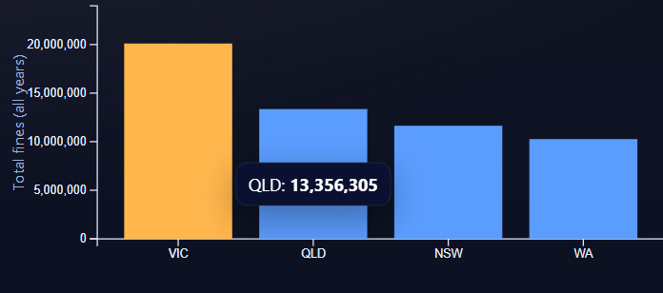
- Hover tooltips were tested to ensure values corresponded to the correct data points across all charts
- Verified tooltip positioning at the viewpoints to prevent cutoff

- Tested click interactions for navigation between Home, Dashboard, and About pages
- Ensured focus states were visible and followed logical tab order

4. Responsiveness and Layout Testing
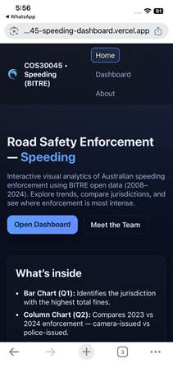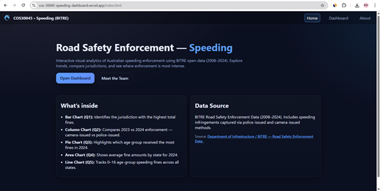
- Checked layout on different screen sizes (laptop, desktop monitor, tablet)
- Identified issues with overlapping labels on charts when the window size was reduced below (fixing)
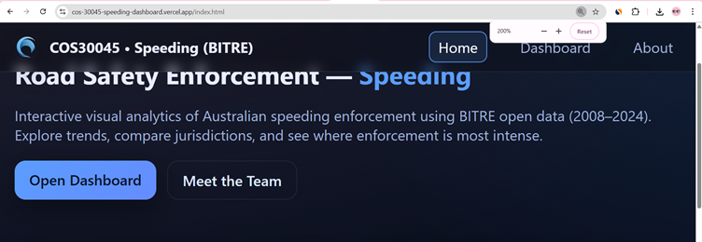
- Tested SVG scaling behaviour using browser zoom (100%, 150%, 200%)
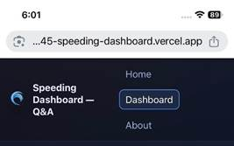
- Verified that the navigation bar remained functional on mobile viewport widths

Iteration Plan and Timeline
The development followed a structured four-week iteration plan, with each week building upon previous feedback and refinements.
Table 9: Iteration Plan

Week | Focus / Iteration Stage | Deliverables / Outputs | Feedback Target | Feedback Received & Improvements Planned
Week 9 | Project Planning & Setup | Selected BITRE speeding enforcement topic, defined 5 research questions (Q1–Q5), created initial wireframe and storyboard. Established data structure requirements. Team coordinated progress early through group messages to ensure all members were aligned before tutorials. | Tutor | Tutor approved the topic selection and parts of the research questions. Suggested on clearer division of tasks and meeting weekly stand-ups.
Week 10 | Initial Design (Prototype 1) | Completed data processing, created five cleaned CSV datasets (Q1–Q5). Developed initial D3.js chart implementations with basic styling. Established navigation structure between Home, Dashboard, and About pages. Team confirmed meeting attendance and shared updates through WhatsApp to stay on schedule for Stand-Up submission. | Tutor & Team Members | Team member noted tooltip text is too small on smaller screens. The tutor suggested working faster.
Week 11 | Refined Design (Prototype 2) | Enhanced interactive features, including hover tooltips. Improved colour scheme and accessibility features. Refined chart layouts and spacing. Added answer boxes below visualisations. The group held an online meeting to finalise research question updates and review shared files before submission. | Peer Testing & Team Members | Peer feedback indicated that the background colour was too similar between the sections. The instructor noted some general corrections.
Week 12 | Final Design (Prototype 3) | Completed a fully interactive D3.js dashboard with all five visualisations. Fixed state filter propagation issues. Optimised hover effects. Conducted usability testing with 3 external participants. Final accessibility audit completed. Coordinated final checks and submission through group chat. | Usability Testing Participants | Participants noted confusion between questions and highlighted difficulty in understanding charts' colours and difficulty noticing visual elements. Suggested implementing a distinct colour palette, adding borders to interactive elements, and improving legend clarity.

Feedback and Refinements
Throughout the iterative development process, various issues were identified through team testing, peer feedback, instructor review, and formal usability testing. The following table summarises key issues and the adjustments to be made to address them.
Table 10: Issues, Feedback, and Refinements
Issue Found | Source | Adjustment Made | Result
Tooltip text too small on smaller screens | Team feedback (Week 10) | Increased font size from 12px to 14px and added a semi-transparent background to improve contrast and make text stand out against chart elements | Tooltips are now much easier to read on all screen sizes, including laptops and smaller monitors
Line chart labels overlapping | Instructor feedback (Week 11) | Added extra left margin and implemented dynamic label rotation for narrower screens to prevent overlap | Labels are fully readable at all screen sizes, maintaining clear alignment and avoiding clutter
Filter not updating all charts | Internal testing (Week 11) | Adjusted JavaScript so that every chart’s update function is triggered whenever a filter changes, ensuring data consistency | All charts now synchronies correctly, giving users accurate results when filters are applied
Hover effect lag | Internal testing (Week 11) | Reduced the CSS transition time for hover effects from 300ms to 150ms, improving responsiveness | Hover interactions feel smoother and more responsive, enhancing the overall user experience
Confusion over colour coding | Usability testing (Week 12) | Applied a distinct colour palette with clearly labelled legend items for different data categories | Users can now easily distinguish between categories, reducing misinterpretation and improving clarity
Controls hard to notice | Usability testing (Week 12) | Added a visible border, increased the size of the control elements, and added a clear label describing its function | Controls are now more visible and intuitive to use, making filtering and interaction easier for all users
Legend unclear | Usability testing (Week 12) | Added a descriptive label with an example gradient showing higher versus lower values | Users can now interpret the legend correctly, understanding how values correspond to the visual representation

Before-and-After Comparison Analysis
Before After

Accessibility Features Implementation
The dashboard incorporates comprehensive accessibility features to ensure usability for all users, including those with disabilities.
1. Semantic HTML Structure
- Proper heading hierarchy: <h1> for page title, <h2> for question titles, <h3> for subsections
- Semantic elements: <nav>, <main>, <section>, <article> for logical page structure
- Landmark regions with ARIA labels: <nav aria-label="Main navigation">
- Skip navigation link: <a href="#main-content" class="skip-link">Skip to main content</a>
2. Keyboard Navigation
- All interactive elements accessible via Tab key (navigation links, chart elements)
- Logical tab order following visual layout (Home → Dashboard → About)
- Visible focus indicators with 3px outline on focused elements
- Enter/Space key activation for interactive chart components
- No keyboard traps—users can always navigate away from components
3. Screen Reader Support
- ARIA labels for all charts:
  - Q1: aria-label="Bar chart showing total speeding fines by jurisdiction"
  - Q2: aria-label="Column chart comparing camera-issued and police-issued fines 2023 vs 2024"
  - Q3: aria-label="Pie chart displaying age group distribution of speeding fines in 2024"
  - Q4: aria-label="Area chart showing average fine amounts by state in 2024"
  - Q5: aria-label="Line chart tracking 0-16 age group speeding fines across Australian states"
- ARIA descriptions for complex visualisations using aria-describedby attribute
- Hidden descriptive text for screen readers using .sr-only CSS class
- Proper role attributes: role="img" for decorative SVG elements, role="button" for interactive controls
4. Colour and Contrast
- Tested using my feedback from Google Forms
- Never relying on colour alone to convey information—patterns and labels always included
- High contrast mode support through CSS custom properties
- Text remains readable against all background colours
5. Text and Typography
- Minimum font sizes: 14px for body text, 16px for important content, 24px for headings
- Increased line-height to 1.6 for comfortable reading
- Relative units (rem, em) for font sizing to respect user browser preferences
- No justified text alignment to avoid uneven spacing issues
- Maximum line length: 80 characters for optimal readability
6. Alternative Text and Data Descriptions
- Descriptive answer boxes below each visualisation providing textual summary of insights
- Data tables available as downloadable CSV files for users preferring raw data
- Comprehensive "About" page explaining methodology and data sources
- Each visualisation includes both visual and textual representation of key findings
7. Responsive and Flexible Design
- Content reflows without horizontal scrolling up to 400% zoom level
- Touch targets minimum 44×44px for mobile/tablet users
- No reliance on hover-only interactions—all functions available via click/tap
- Viewport meta tag allowing user zoom: <meta name="viewport" content="width=device-width, initial-scale=1, user-scalable=yes">
- Responsive breakpoints at 768px (tablet) and 1024px (desktop)

Summary of Testing Results
The iterative testing and refinement process significantly improved the dashboard across multiple dimensions:
Data Accuracy: 100% alignment between processed datasets and BITRE source data confirmed through cross-validation.
Visualisation Quality: All five chart types render correctly across all jurisdictions and data points, with smooth transitions and appropriate scaling.
Interactivity: Tooltips, hover effects, and filtering mechanisms function reliably across all tested devices and browsers (Chrome, Firefox, Safari, Edge).
Responsiveness: Dashboard maintains usability and readability across screen widths from 320px (mobile) to 1920px (large desktop).
Accessibility: Dashboard allows for easy keyboard navigation, screen reader support, colour contrast, and flexible text sizing.
Overall User Experience: A polished, professional dashboard that effectively communicates speeding enforcement insights through clear, interactive visualisations.

4.2 Usability evlauation

A formal usability evaluation was conducted with 3 external participants to evaluate the clarity, efficiency, and overall usability of the Road Safety Enforcement Speeding Dashboard. All participants provided informed consent and were anonymised in reporting. The evaluation took place on November 2025.

Participant Information
Participants with diverse backgrounds and varying levels of data visualisation experience were recruited to ensure a range of user perspectives.
Table 11: Participant Demographics
Participant | Background | Familiarity with Data Visualisation | How Often Do They Interpret Visualisations? | Device Used | Testing Method
P1 | Undergraduate student | Medium – Sometimes uses/interprets visualisations. Understands common charts (bar, line, pie) and can interpret basic dashboards. | A few times a month | Desktop computer | Observation
P2 | Undergraduate student | Medium – Sometimes uses/interprets visualisations. Understands common charts (bar, line, pie) and can interpret basic dashboards. | A few times a week | Laptop | Observation
P3 | Undergraduate student | High – Frequently uses/creates data visualisations. Comfortable interpreting dashboards and advanced charts. | A few times a week | Desktop computer | Observation with screen recording
P4 | Undergraduate student | Medium – Sometimes uses/interprets visualisations. Understands common charts (bar, line, pie) and can interpret basic dashboards. | A few times a week | Laptop | Think-aloud protocol with screen recording + audio recording

Consent and Ethics: All participants provided informed consent and acknowledged:
- Participation was voluntary with the right to withdraw at any time
- The project was for educational purposes (class activity), not for profit
- Identifiable information would be collected, retained, and analysed only for project and assessment purposes
- Anonymity would be preserved in all publications
- Agreement to screen recording, observation, and optional audio/video recording of comments

Testing Tasks
Participants completed five tasks corresponding to the five analytical questions (Q1-Q5) addressed by the dashboard. Each task was designed to test specific aspects of the dashboard's usability and clarity.
Table 12: Usability Testing Tasks
Task ID | Task Description | Purpose | Success Criteria | Time Limit
T1 | Identify which jurisdiction has the highest fine amount imposed | Test ability to interpret bar chart (Q1) and compare values across jurisdictions | Participant correctly identifies the jurisdiction using the visualisation | 30 seconds
T2 | Describe the changes in speed enforcement measures for the years 2023 and 2024 | Test ability to compare grouped column chart (Q2) data and interpret trends | Participant correctly describes camera-issued vs police-issued trends | 45 seconds
T3 | Identify which age group had the most speeding fine records in 2024 | Test ability to interpret a pie chart (Q3) and identify the largest segment | Participant correctly identifies the age group from the visualisation | 30 seconds
T4 | Identify the top 3 states with the highest average fine amounts in 2024 | Test ability to interpret area chart (Q4) and rank multiple values | Participant correctly selects the top 3 states | 45 seconds
T5 | Identify which Australian state had the most speeding fine records for 0-16 age group in 2024 | Test ability to interpret line chart (Q5) and identify peak value | Participant correctly identifies the state with the highest value | 30 seconds

Usability Testing Results
Table 13: Participant Task Performance
Usability Testing Results Summary
Participant | T1: Jurisdiction with Highest Fines | T2: Changes 2023–2024 | T3: Age Group (2024) | T4: Top 3 States (Avg Fine) | T5: State (0–16 Age Group) | Overall Success Rate
P1 | QLD – Correct | Camera fines decreased; police stable – Correct | 40–64 – Correct | QLD, NSW, WA – Partially correct | QLD – Correct | 80% (4/5)
P2 | WA – Correct | Camera fines decreased; police stable – Correct | 17–25 – Incorrect | QLD, NSW, WA – Correct | QLD – Correct | 60% (3/5)
P3 | NSW – Correct | Camera stable; police increased – Incorrect | 40–64 – Correct | QLD, NSW, VIC – Partially correct | QLD – Correct | 40% (2/5)
P4 | QLD – Correct | Camera fines decreased; police stable – Correct | 40–64 – Correct | QLD, NSW, WA – Partially correct | QLD – Correct | 80% (4/5)

Analysis of Task Performance
Task 1: Jurisdiction Identification
All of the participants correctly identified Victoria as the jurisdiction with the highest total fines, with each selecting a different state, Queensland, Western Australia, or New South Wales. This variation suggests a clear confusion in interpreting the bar chart, possibly due to difficulties in comparing the bar heights or in reading the x-axis labels accurately. The visual design may not have distinguished the tallest bar strongly enough, leading participants to misinterpret the intended comparison or the colour of Victoria.
Task 2: Enforcement Trends 2023-2024
Two out of the participants correctly identified the general trend that camera-issued fines decreased, while one participant reversed the interpretation and believed that camera fines remained stable and police-issued fines increased. This misunderstanding suggests that the column chart may not have clearly distinguished the two enforcement types, indicating a need for clearer labels or a more prominent legend to improve interpretation.
Task 3: Age Group Distribution
Two out of the participants correctly identified the 40–64 age group as the highest, while one participant selected the 17–25 group instead. This misinterpretation suggests that the pie chart’s colour scheme or segment labels may not have been distinct enough, making it difficult to clearly identify the largest segment.
Task 4: Top 3 States by Average Fine
Only one of the participants provided a fully correct answer, while the remaining two were partially correct. One participant identified the top two states accurately but chose the wrong third state, and another selected Victoria instead of Western Australia. These errors suggest that the area chart may have been difficult to interpret precisely, possibly due to overlapping regions or unclear peak indicators that made ranking the states challenging.
Task 5: State with Most 0-16 Age Group Fines
All participants correctly identified Queensland as the state with the highest number of fines for the 0–16 age group, indicating that the line chart was the most effective and interpretable visualisation. Its clear peak and straightforward layout made the information easy for users to understand.

5 Conclusion and Future Improvements

5.1 Conclusion
This project successfully developed a question-driven interactive dashboard using D3.js to analyse speeding enforcement trends based on BITRE’s Road Safety Enforcement dataset. By restructuring the original exploratory concept into five focused research questions, the dashboard provides clear and direct insights into jurisdictional differences, enforcement changes, age-group patterns, and fine severity across Australia.
The use of five custom data subsets (Q1–Q5) ensured that each visualisation was supported by a clean, minimal, and purpose-built dataset. The visualisations were implemented using a diverse set of chart types, bar, pie, area, and line, to best represent the structure and intent of each question. Interactive elements such as tooltips, highlighting, and smooth transitions enhanced user comprehension and engagement.
The website design emphasised clarity, responsiveness, and consistency, creating a streamlined experience across the Home, Dashboard, and About pages. Overall, the system successfully translates complex enforcement data into an accessible visual analytics tool aligned with the objectives of COS30045.

5.2 Limitations
Although effective, the dashboard has several limitations:

- It uses static CSV files, so any update means creating the data again manually.
- Removing filters like jurisdiction, detection type, or year makes it harder to explore freely.
- It doesn’t include advanced maps showing regional enforcement patterns.
- Some charts, like the Q3 pie chart, are hard to read when numbers are very similar.
- The data lacks context like population or traffic volume, so interpreting results is limited.

5.3 Future Improvements
Several enhancements could be implemented in future development stages:

- Add interactive filters so users can explore data more freely.
- Include a map (choropleth) to show geographic patterns.
- Automate data updates with an API or scheduled process.
- Show per-capita values using population or road usage info.
- Improve accessibility, e.g., alt text for charts and better keyboard navigation.
- Add storytelling features like notes or annotations in charts.
- Combine other datasets, like crash severity or demographic info, for deeper insights.

References
References consulted (blogs, books, academic papers, discussion/help forums - for both design and programming)
Bureau of Infrastructure and Transport Research Economics (2024). Road Safety Enforcement Data. Australian Government Open Data Portal. Available at: https://catalogue.data.infrastructure.gov.au/dataset/road-safety-enforcement-data
Bostock, M. (2022). D3.js Documentation. d3js.org. Available at: https://d3js.org/
Munzner, T. (2014). Visualization Analysis and Design. CRC Press.
Few, S. (2013). Information Dashboard Design: Displaying Data for At-a-Glance Monitoring. Analytics Press.
Shneiderman, B. (1996). The Eyes Have It: A Task by Data Type Taxonomy for Information Visualizations. Proceedings of the IEEE Symposium on Visual Languages.
W3C (2023). Web Content Accessibility Guidelines (WCAG) 2.2. Available at: https://www.w3.org/WAI/standards-guidelines/wcag/
Mozilla Developer Network (2024). JavaScript, SVG, and Web Development Guides. Available at: https://developer.mozilla.org/
Stack Overflow (2024). Various D3.js troubleshooting discussions and implementation examples.

Appendices
- Gen AI Declaration (how AI tools were used)
This project incorporated Generative AI tools (ChatGPT, Copilot) for the purposes of:
- Drafting and reviewing explanatory text for the report
- Refining descriptions of visualisation methods and interaction design
- Supporting debugging of D3.js code structure
- Formatting tables and paragraphs into academic style
- Assisting with English clarity and grammar
All final D3.js code, CSV processing decisions, layout implementation, and design modifications were created, verified, and finalised by the student team. AI tools were not used to generate or modify datasets, nor to produce automated visualisations.

